**../../../../../../../Pictures/ARA/Pics/ARA%20LOGO/ARA%20master%20shield%20lo KENT ACTIVE ../../../../../../../Pictures/ARA/Pics/ARA%20LOGO/ARA%20master%20shield%20lo**

**THE NEWSLETTER OF THE KENT ACTIVE RETIREMENT ASSOCIATION**

**Volume Eighty Springy 2022 No. 87**

***Circulation: ∞***

***“Do not think of retirement as someone closing a door on a bright, and crowded street.***

***Think of it as someone opening the door to a beckoning and uncluttered world.”***

**John Hardiman *(Found the Association)***

***Happy New Year from the Officers of the KentARA Committee***

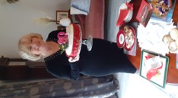  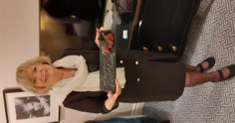

**Surprise Birthday Party The Garrick Theatre The Waldolf Hotel, London**

**Good Morning,**

**How are you all, hope you are keeping well, and pleased to hear KentARA has survived the pandemic. I understand your Clubs are getting back to normal with speakers,**

**day trips, and some short breaks.**

**KentARA is up and running with all Halls and events for the year booked, starting with**

* ***CANCELLED* The Quiz 23rd March *CANCELLED***
* **AGM 7th April. Ditton Community Centre.**
* **Tea Dance 11th May. Ditton Community Centre.**
* **Short Mats Bowls competition 25th August. Ditton Community Centre.**
* **Race Afternoon 20th October. Ditton Community Centre.**
* **Thanksgiving Service 28th October. Rochester Cathedral**
* **Tea Dance 11th November. Ditton Community Centre.**
* **Ten Pin Bowling, Competition. November – TBA**
* **The KentARA Great Christmas Concert 8th December. Ditton Community Centre.**

**The Beautiful KentARA Cruise on The Bolette ship to The Norwegian Fjords, is on 14th September, with Special complementary free drinks and free tips if booked before 15th March 2022.**

**This is a wonderful scenic cruise with beautiful trips. KentARA Group Drinks Party on board. Transfer to and from Dover, hope some more clubs can join us.**

**The Kent Active will continue on line, with a small amount of hard copies being printed for members without a computer. Remember copies can be printed from the website.**

**The KentARA website.** [**https://kentara.weebly.com/photos.html**](https://kentara.weebly.com/photos.html)

**Let’s make it a year to remember.**

**Love & best wishes to you all. Joan Rhodes X**

**KentARA Chairlady (01732) 844 953** [**rhodjo@aol.com**](mailto:rhodjo@aol.com)



**Photograph by Graham Pover. Graham can be contacted at** [**gpoverphotography@btinternet.com**](mailto:gpoverphotography@btinternet.com)

**2021 -- ANOTHER STRANGE YEAR**

**Another year gone, here we are again**

**And despite everything we’re remaining sane!**

**We have survived another very strange year,**

**While hoping that COVID would disappear.**

**We had our vaccines to help keep us safe,**

**And carried on doing the ‘track and trace’.**

**We kept our distance, and wore our masks**

**As we continued with our daily tasks.**

**Normality returned for a while**

**Making us feel better, making us smile.**

**Restrictions were lifted we felt much better**

**Not having to obey the rules to the letter.**

**Holidays abroad did not go ahead.**

**We had lovely breaks in this country instead.**

**A staycation now was the buzz word,**

**One which before had never been heard.**

**A normal existence slowly returned,**

**Back to things for which we had yearned.**

**Holidays, day outings, and theatre trips too**

**Brought back fun, and laughter for us all it is true.**

**Club meetings, and talks were back once more**

**Meeting friends again made us happy for sure.**

**Exercise classes were enjoyed once again**

**Though after so long we suffered some pain!**

**Hopefully this poem finds you all fit and well**

**With many joyful Christmas tales to tell.**

**Let’s hope the new variant will soon disappear**

**And we will all have a happy, and healthy new year.**

**Happy New Year Everyone.**

**From, Christine Kent.**

**SIDARA**

***‘Sid Strikes Back’***

**SIDARA after the lock down opened its doors again in August 2021.**

**About 80 members were present at the first meeting, and although it was only a chat, and a cuppa, it did show people we were ready to meet again.**

**The days out committee quickly organised a lurch at Hunters Meet, Hatfield Heath, and seats on the coach were snapped up at the September meeting, and everyone enjoyed a lovely lunch, some dancing, and entertainment by Chris on guitar. We came away feeling, YES! YES! YES! - we are back in business.**

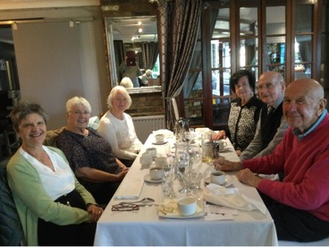

***What, no Champagne?!***

**Maureen, our lady who organises local lunches, also quickly booked a lunch at a restaurant in Sidcup which was enjoyed by those who attended.**

**Eileen managed to obtain a speaker for our November meeting, so I think we are back to normal, fingers crossed.**

**Gill our holidays organiser also arranged a wonderful November holiday to Babbercombe in Devon, where 31 members enjoyed a chilly, but bright rain free 5 days.**

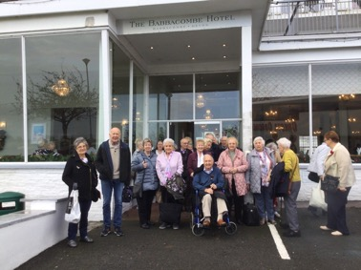

***The ‘Blockade of Babbercombe’.***

**As a gesture of good will, the committee decided to reduce the membership fee for the coming year, and this was welcomed by the 120 members who renewed their membership, although this number is down on previous years, we are sure new members will join us soon.**

**Our Christmas party 2021 was an afternoon tea, but the entertainer that was booked cancelled at the last minute due to illness, but our own member, Alan Harris, stepped in at very short notice, and saved the day with games, and music for dancing.**

**Alan, are a gem - Thank You.**

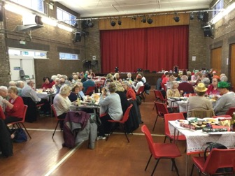

***Christmas Tree Party***

**Brenda also produced a wonderful raffle with over 20 prizes, so another success.**

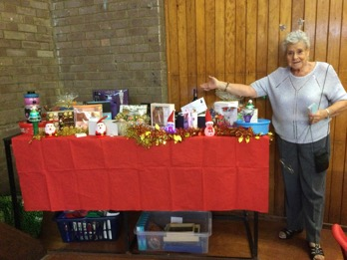

***Brenda the Star Prize***

**A comprehensive programme of events are planned for 2022, with trips to Brick Lane for the Pantomime, and a coach, with lunch at the Star Inn, Normans Bay.**

**There is also a coach trip to Lavenham & Finchingfield, with a Cream tea, and a river boat trip from Windsor with a luxury afternoon tea. Then there is a visit to Chatham Dockyard for the 40’s tribute weekend in September 2022.**

**So yes, we can truly say SIDARA is fighting back.**

**It is sad we lost several members to Covid-19, and we offer our deepest sympathies to the families, and friends of these members.**

**At the time of submitting this article for inclusion in the KENTARA ‘Kent Active’ magazine, the new ‘Omnicron’ variant of the Covid-19 virus has started to spread; so from SIDARA to all KENTARA members, do stay safe, and best wishes to you all for 2022.**

**From Shelia Norris of SIDARA**

**Please send your Club pictures, and news stories to the KentARA website via our Webmistress Pat Cox at pmc1948@live.co.uk**

**Visit the KentARA website at,** [**https://kentara.weebly.com/photos.html**](https://kentara.weebly.com/photos.html)

**Please ensure that all pictures you send have the permission of those who appear in them, to be published.**